Study the codes from github ksudana’s repository.

This code supports querying and visualization of market analysis data scraped from Yahoo Finance.

Firstly, import data from Yahoo Finance,

Then build its filter and analysis the data.

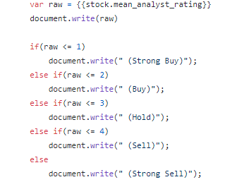

Each stock is assigned with a ranking value.

For example, If the value <1, ->strong but.

If value >4, ->strong buy.

The stock with the lowest value is the rank1 stock that worth to buy.

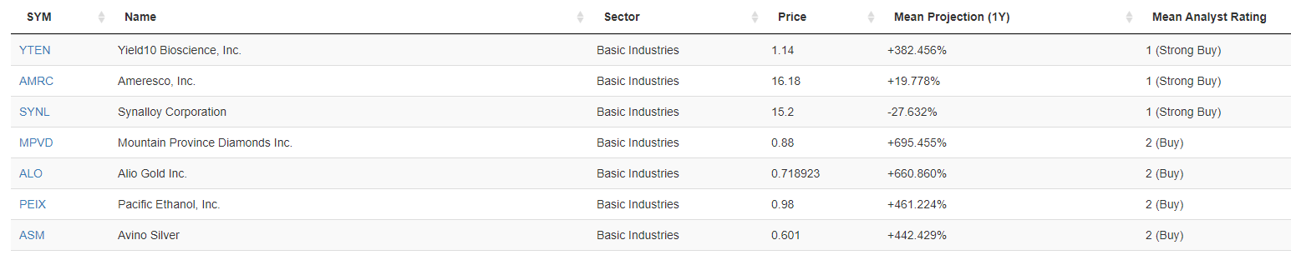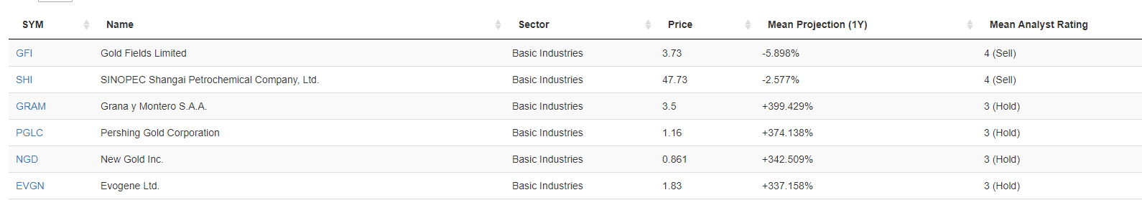

Reference link：

<https://github.com/ksudana/market-rank>